April 12, 2022

Mr. Robert Burton
Ms. Claire Burton
5331 N Sundown
Tucson, Arizona 85718

Re: TownePlace Suites by Marriott

Dear Bob and Claire:

Our Marriott TownePlace is making a distribution to the Partners. Attached are two checks, one to each of you for $135,000, for a total of $270,000! You each own 15%, for a total of 30%.

We accumulated cash though covid and are distributing the extra cash.

As you remember, you received this 30% ownership as part of our Apartment and Hotel deal.

Just to summarize, you invested $7 million in El Dorado and Comfort Suites. This transaction saved you from having the pay the IRS approximately $3.2 million. By doing this deal, the tax burden became ours, and you received a guaranteed 8% on your money, plus the 30% investment in the Marriott. Our properties were never for sale, I came up with the plan so that you could invest money that would have gone to the IRS and earn a return, effectively doubling your return on the money you would have originally been left with. Your concern of protecting your investment was achieved by BWL guarantying your investment and your return.

Of your original investment of $7 million, we loaned you back $4.4 million. Thus, your current cash investment is $2,600,000. You currently receive $17,333.33 per month on this investment.

With these latest checks from Marriott, you have received $1,577,042.43 in cash flow. Here is a breakdown:

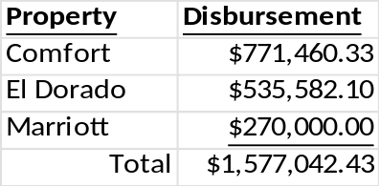

I hope you are happy with the plan we came up with and are happy with your investment with our company.

Sincerely,
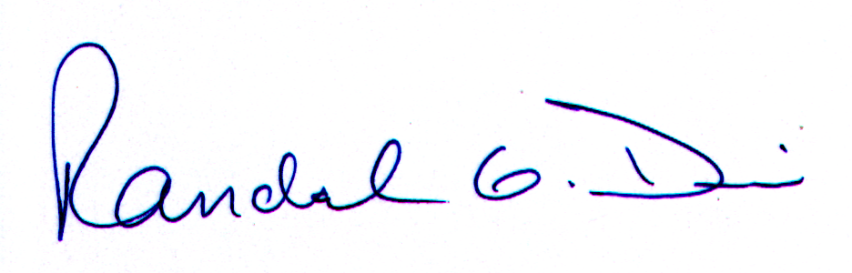
Transwest Properties, Inc.

Randal G. Dix, Vice President

